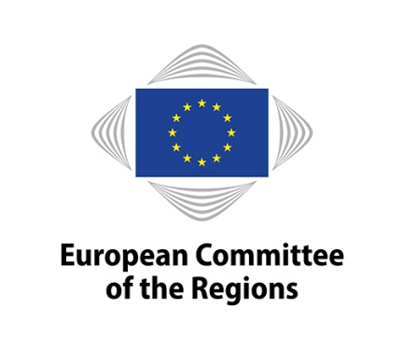

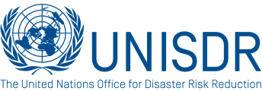

European Committee of the Regions and United Nations Office for Disaster Risk Reduction Joint Conference

Disaster Risk Management in European Regions and Cities
Towards reducing the number of affected people

Agenda

Venue: European Committee of the Regions, Rue Belliard 101, Brussels, room JDE 51
Date: 12 October 2017, 14:30h-17:00h
Language Regime: Interpretation available in EN, DE, FR, IT, PL

14:00 Registration

14:30 High – level plenary session

- Mr. Karl –Heinz LAMBERTZ (BE/PES), President of the European Committee of the Regions
- Ms. Corina Crețu, European Commission, Commissioner for Regional Policy
- Mr. Robert Glasser, UNISDR, Special Representative of the Secretary General

15:00 Local and regional authorities: Key players in disaster prevention.

The session will focus on best practices in reducing disaster risk, lessons learned and prevention-related policies.

Moderator: Mr. Adam BANASZAK (PL/ECR), CoR Rapporteur, Vice-president of Kujawsko-Pomorskie Regional Assembly

- Mrs. Catiuscia Marini (IT/PES), President of the Umbria Region, Italy
- Mrs. Nacira BOULEHOUAT, European Commission DG ECHO - Head of Unit "Disaster Risk Reduction, European Voluntary Humanitarian Corps"
- Mr. Herwig van Staa, President of the Regional Parliament, Tyrol, Austria
- Mr Hannes Kont – Deputy Secretary General for Rescue Policy and Crisis Management, Ministry of Interior, Estonia

- Q&A session and discussion

16:00 Closing the gaps in disaster risk governance

The session will focus on financing of projects, funding instruments and the role of private companies, as well as avoiding economic downturn after disasters.

Moderator: Mr. Vito Santarsiero (IT/PES), CoR rapporteur, Member of the Basilicata Regional Council

- Mr. Leonard Reinard, European Investment Bank, Head of Division
- Mrs. Alanna Simpson, World Bank, Regional Coordinator for Europe and Central Asia
- Mr. John Scott, Chief Risk Officer Commercial Insurance, Zurich Insurance Company
- Mr Pavel Branda (CZ/ECR) Deputy-mayor of Rádlo Municipality, chairman of the
Interregional group on cross-border cooperation of the CoR

- Q&A session and discussion

17:00 Conclusions
Moderator: Mr. Harvey Siggs (UK/ECR), CoR Rapporteur, Leader of Mendip Council

- Professor Mr. Angelo Masi, University of Basilicata, IT
- Contributions from the audience
- Conclusions by Mr. Harvey Siggs

